
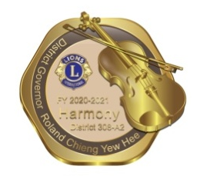
LCI District 308-A2
(FY 2020-2021)
(Brunei Darussalam, Sarawak, Sabah & FT Labuan)

REIMBURSEMENT CLAIM

NAME OF CLAIMANT | : |  | DATE | :
POSITION | : |  | REGION | : ZONE :
EVENT TITLE | : |  | DATE | :

NO. | BILL | DESCRIPTION | AMOUNT
 |  | TOTAL (RM) :

REMARKS: | …………………………………………….  Signature of Claimant

Please fill in your Bank Information as bellows:
Payable To | :
Bank Name | : | Bank Account No. | :
** Note: All necessary documents or bills to be presented with the attached Claim Form.

For Office Use Only
Date Received : ……………………………………………… |  |  |  | Date Disbursed :
Receiver Name : …………………………………………….. |  |  |  | Cheque No. :
Signature : …………………………………………………….. |  |  |  | Approved by : …………………………………………………...  District Governor
Ref. No. : ……………………………………………………… |  |  |  | Approved by : …………………………………………………...  District Governor
Bill / Invoice Received ( ) |  |  |  | Approved by : …………………………………………………...  District Governor

